SUGGESTED EXERCISES

Observing the sharing of hugs
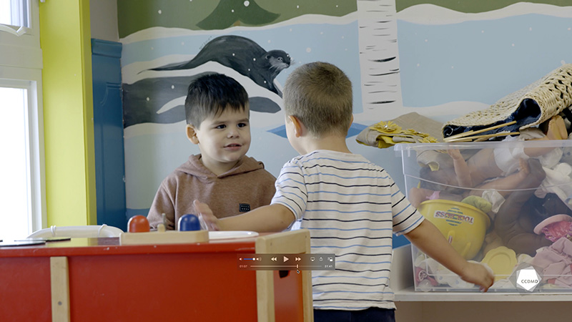
Video: The power of hugs

Objectives
- Analyzing the profession.
- Building a positive relationship with children.
- Building a relationship of trust with children’s families.
- Working with children with special needs.
- Assessing educational quality.

Activity details
Approximate duration: 3 hrs

STEP 1 (to be done in advance)
- One week before class, search for an inclusion or integration policy for children with special needs in your workplace or online.
- Read the policy.
- Bring it to your next class.
STEP 2
- Watch the video clip as a group or individually.
STEP 3
- In teams of two or three, share the key elements of the policy and any questions you have with the group.
- Answer the questions in the table below:
- Referring to what you can see in this clip and in the policy that you chose to bring to class, note the elements that respect the principle of educational inclusion for welcoming children with special needs positively.
- What elements of the clip and the policy promote the inclusion of children with special needs?
- What elements of the policy could be improved to ensure a more meaningful inclusion for children and their families?
STEP 4
- When you return to the classroom, share your answers with the group.
STEP 5
- As a group, conclude the discussion by answering the following questions:
- What is your takeaway from this exercise?
- What did you find easy or difficult to do, and why?
- If you were in a team meeting and were asked to suggest any improvements to the inclusion policy for children with special needs, would you be comfortable to do so? Why?
- What are the rights of children with special needs who are attending educational childcare centres (ECCs), and what are the responsibilities of ECCs with regard to those rights?

Additional suggested exercises
- Note any elements from the clip that show that the child is seeking to establish contact and is open to building relationships with the other children or adults.
- Draft an anecdotal account of the moment when the boy is receiving hugs. Keep in mind that the parents will read it.
- Organize a sharing circle to further explore the issue of inclusion and, particularly, to appropriately distinguish between integration and inclusion.

