SUGGESTED EXERCISES

Observation of a song circle
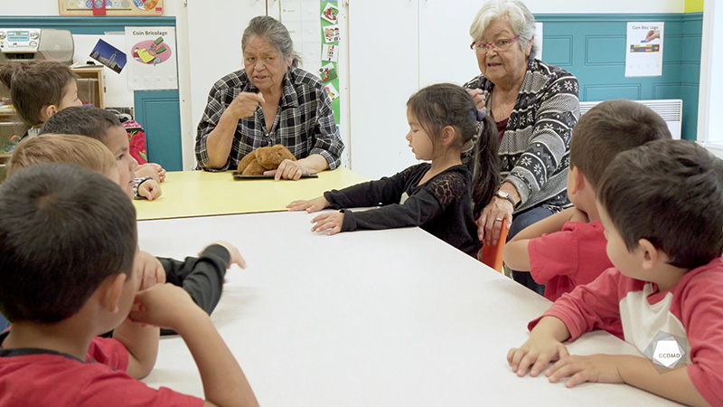
Video: Song in Innu

Objectives
- Establishing positive communication in an educational childcare centre.
- Promoting children’s holistic development.
- Observing the development and behaviour of children.
- Building a positive relationship with children.
- Promoting positive behaviour among children, individually or as a group.
- Planning democratic educational interventions.
- Facilitating active learning-based educational interventions.
- Integrating the language and culture of belonging into educational practices.

Activity details
Approximate duration: 3 hrs

STEP 1
- Watch the video clip as a group or individually.
STEP 2
- In teams of two or three, think of a situation where you would have invited an Elder to facilitate a cultural transmission activity for the children at your educational childcare centre (ECC).
- Share each team’s initiatives in relation to this theme with the group.
STEP 3
- Explain how the two Elders can be observed fostering a positive environment in this clip by answering the following questions:
- What is a positive environment?
- What are examples of positive moments you can observe in this clip?
Here are two examples:
- The Elder starts the activity by offering a choice of song to the children, which could be viewed as the adult taking the children’s point of view into account.
- A positive vibe can be observed in this clip through the following interactions: close proximity between the adult and the children, both adults facilitate the activity and take part in it as well, they smile a lot, a child hugs one of the Elder, and she responds by affectionately stroking their hair.
- The relationships that the kukums are able to build between themselves, the children and the rules of life also contribute to the vibe. Positive interpersonal relationships foster discovery, learning and creativity. For instance, in this clip, the adults can be seen taking the time to observe the children.

STEP 4
- Expand your learning by self-assessing your ability, as a future educator, to foster a positive vibe. Ask yourself the following question: How will I manage to establish a positive environment when I become an educator?
- Fill out the table below individually.
- It is also possible to review it with the group.
PEDAGOGICAL INTERVENTIONS | HOW CAN I ACHIEVE IT?
I take the time to welcome each child.
I encourage the children to explore their mother tongue.
I support their elementary skills.
I value their progress.
I give the children the opportunity to use their newly acquired knowledge, language skills and cultural skills.
I protect children from inappropriate punishment.
I communicate with the children using a rich vocabulary and accurate words.
I help the children to manage their own behaviours.
STEP 5
- Expand your learning by further discussing the following questions:
- What is your takeaway from this activity?
- What do you think of this Innu song activity?
- How does the adults’ non-verbal communication impact the children?
- What songs related to your culture do you sing with the children? Why?

Additional suggested exercises
- Write a song or a story in your mother tongue and share it with the group.
- Draw a mind map on the importance of learning one’s mother tongue. To learn more about mind maps, read the following: https://en.wikipedia.org/wiki/Mind_map

