SUGGESTED EXERCISES

Observing solitary play
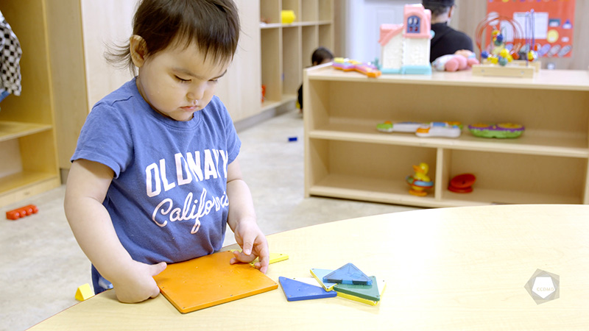
Video: Solitary play

Objectives
- Promoting children’s holistic development.
- Observing the development and behaviour of children.
- Organizing the educational environment.
- Integrating the language and culture of belonging into educational practices.
- Working with children with special needs.

Activity details
Approximate duration: 3 hrs
STEP 1
- Watch the video clip as a group or individually.

STEP 2
- Research the developmental stages of the pencil grasp in children.
- Make connections between your research and the video clip.
STEP 3
- Take turns sharing the connections between your research and the video clip.
STEP 4
- Watch the video clip for a second time as a group or individually.
STEP 5
- Try to expand on your observations by answering the following questions in writing:
- Are the materials in the play area representative of the culture of belonging?
- How could the materials be more representative?
STEP 6
- Share and compare your answers with the group.
STEP 7
- Answer the following questions as a way to consolidate and recap what you have learned:
- What is your takeaway from this activity?
- What could you introduce (in terms of materials and room layout) to this space if you were to accommodate a child with special needs?
HERE’S AN EXAMPLE OF A REFERENCE, WHICH PROVIDES VISUAL TOOLS AND EXPLANATIONS, TO INCORPORATE AS PREPARATION FOR THIS EXERCISE:
https://montessorimaispasque.com/2015/03/26/le-developpement-de-la-main-du-bebe-et-ladaptation-des-propositions/

