SUGGESTED EXERCISES

Observation of outside playtime
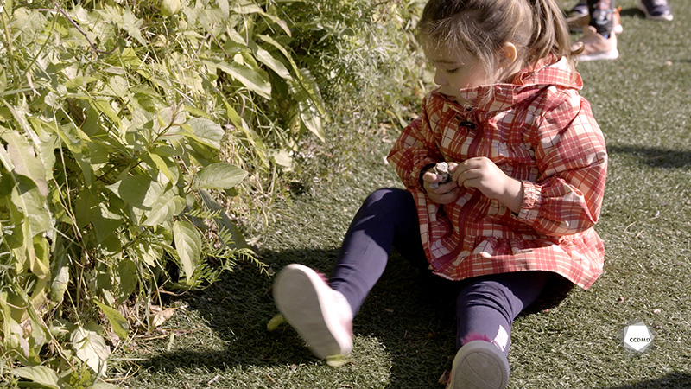
Video: Playing with rocks

Objectives
- Promoting children’s holistic development.
- Observing the development and behaviour of children.
- Planning democratic educational interventions.
- Organizing the educational environment.
- Facilitating active learning-based educational interventions.
- Integrating the language and culture of belonging into educational practices.
- Assessing educational quality.

Activity details
Approximate duration: 4 hrs

STEP 1
- In the table below, note the elements of observational theory you are familiar with and those you would like to learn or explore further.
What I know about observation | What I’d like to learn more about
STEP 2
- Watch the video clip as a group or individually.

STEP 3
- As you watch, write down everything you observe in this clip.
MY OBSERVATIONS
STEP 4
- Watch the video clip for a second time as a group or individually.
STEP 5
- Make connections between your observations and the spheres of development of the child playing with rocks.

SPHERES OF DEVELOPMENT
Social
Affective
Motor
Language
Cognitive
Cultural
Spiritual
Sexual
STEP 6
- Make connections between your observations, the spheres of development and the theories of development. Write down your thoughts on the image and in the tables below:
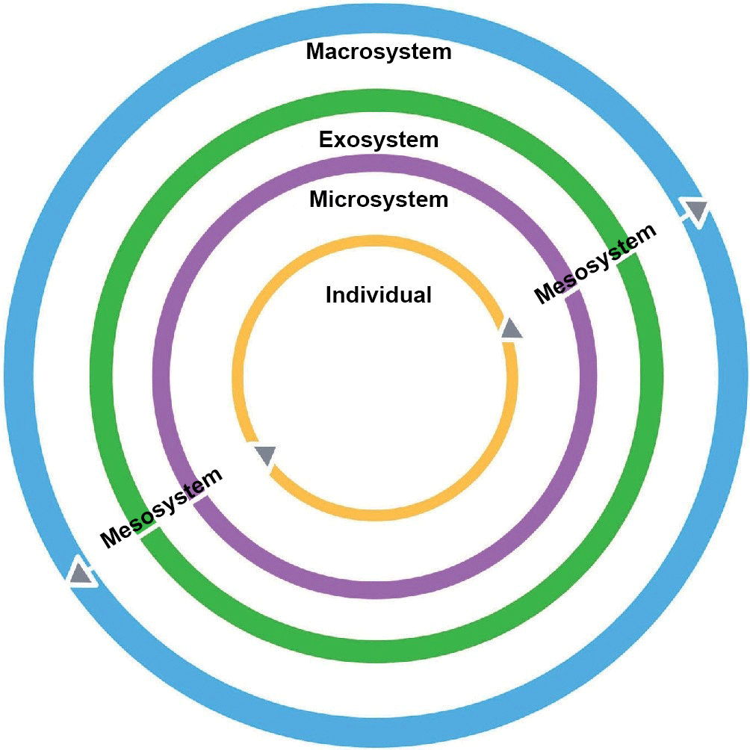
- ECOLOGICAL APPROACH

(Inspired by Bronfenbrenner’s theory)

- OTHER APPROACHES
Psychodynamic theory

Behavioural theory

Humanistic theory

Cognitive theory

STEP 7
- In keeping with the video clip and the spheres of development, identify some educational strategies to implement.

