SUGGESTED EXERCISES

Observing a group of children playing
with blocks
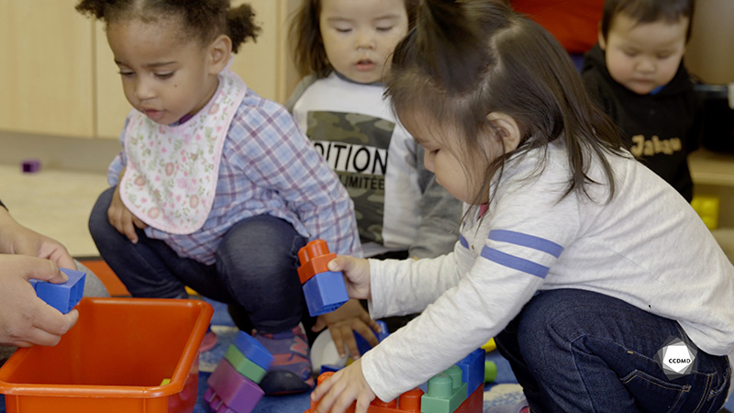
Video: Playing with blocks

Objectives
- Analyzing the profession.
- Promoting children’s holistic development.
- Observing the development and behaviour of children.
- Building a positive relationship with children.
- Promoting positive behaviour among children, individually or as a group.
- Planning democratic educational interventions.
- Organizing the educational environment.
- Facilitating active learning-based educational interventions.
- Assessing educational quality.

Activity details
Approximate duration: 3 hrs
STEP 1
- Watch the video clip as a group or individually
STEP 2
- Individually or in teams of two, note in the table below the elements you observed in the clip that show that the educator allows children to stay engaged in their actions, to develop their skills and to learn.
Observations that show that the educator allows children to stay engaged in their actions.
Observations that show that the educator allows children to develop their skills.
Observations that show that the educator allows children to learn new concepts and take on challenges.
STEP 3
- Share your observations with the group.
- Ask questions and have a group discussion.
STEP 4
- Watch the video clip for a second time as a group or individually.
STEP 5
- Reflect on the following questions:
- Can you recall a situation where you were in an educational role with children?
- What actions did you take to demonstrate your modelling skills (carrying out your role to allow children to stay engaged in their actions and develop their skills and to support their learning)?
- What more could you have done?
- Note your reflections in the table below:
Describe the situation.
What actions did you take that demonstrated your modelling skills?
What more could you have done?
STEP 6
- Share your reflections with the group.
- Set some time aside for questions and discussion.

Additional suggested exercises
- In teams of three or four, select one child from the video clip. Watch the clip, and observe the child to note their verbal and non-verbal behaviours. Then, try to identify a few characteristics of the child’s temperament.
- Shadow educators in a childcare centre and observe them throughout the day to note pedagogical behaviours that demonstrate how they apply the notion of modelling with the children.

