SUGGESTED EXERCISES

Observation of outside playtime
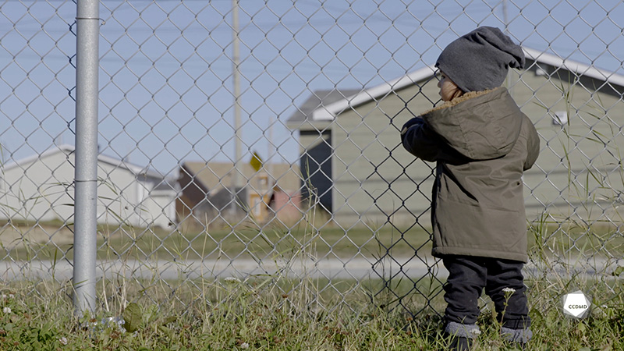
Video: Outside play

Objectives
- Analyzing the profession.
- Observing the development and behaviour of children.
- Assessing educational quality.

Activity details
Approximate duration: 4 hrs
STEP 1
- Watch the video clip as a group or individually
STEP 2
- Note as many elements as you were able to observe while watching the video clip in the table below (spontaneous observation).
Note here all the elements that were spontaneously observed.
STEP 3
- Everyone shares their observations with the group.
Notice your colleagues’ observations and what struck them the most in this outside playtime period. Take note of the most relevant ideas or observations.
STEP 4
- Watch the video clip for a second time as a group or individually.
STEP 5
- Note any elements relating to the child who is playing with the fence only (in terms of fine motor skills and connection with nature).
Observations: fine motor skills/child playing with the fence

Observations: connection with nature/child playing with the fence
STEP 6
- Compare your notes from steps 2 and 5 and answer the following questions:
- What are the differences between spontaneous observation and guided observation?
- Is it necessary to ask questions or to be experiencing a problematic situation to observe something? Why?
- What are the benefits of observing one situation more than once, but with different goals? What are the disadvantages?
- Do you believe that observing one particular situation with a well-defined goal can help you to improve your sense of observation? Why?
STEP 7
- Watch the video clip for a third time as a group or individually.

STEP 8
- Answer the following questions in writing based on your observations:
  - How can you stimulate the development of fine motor skills for all the children in the group while giving them the opportunity to connect with nature?
STEP 9
- Compare your answers with the group.
STEP 10
- Answer the following questions as a way to consolidate and recap what you have learned:
- What is your takeaway from this activity?
- What did you learn about your skills?
- What did you learn about observation and its role in your work?

Additional suggested exercises
- Discuss the following topics in a sharing circle:
  - Five-sense learning
  - Outside play
  - The importance of playing outside of fenced areas and backyards
- Make a list of the materials needed for a threading and braiding activity on the outside yard fence.
- Imagine interacting with the child who is playing with the fence, and explain what you would do to support his exploration and enhance his learning.

