SUGGESTED EXERCISES

Observing naptime customs and traditions
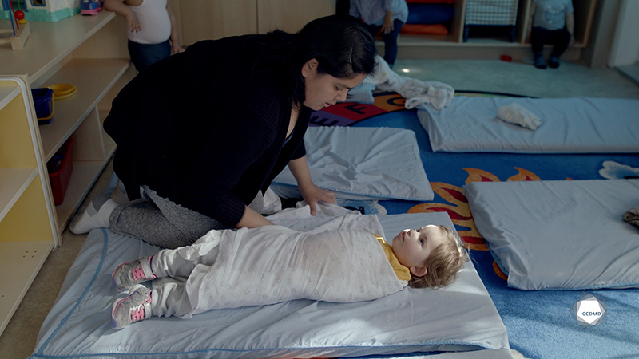
Video: Naptime customs and traditions

Objectives
- Analyzing the profession.
- Promoting children’s holistic development.
- Observing the development and behaviour of children.
- Building a positive relationship with children.
- Building a relationship of trust with children’s families.
- Planning democratic educational interventions.
- Organizing the educational environment.
- Facilitating active learning-based educational interventions.
- Integrating the language and culture of belonging into educational practices.
- Assessing educational quality.

Activity details
Approximate duration: 3 hrs
STEP 1
- Watch the video clip as a group or individually
STEP 2
- Also watch the clip titled “Swaddling a doll” as a group or individually.
STEP 3
- Write a story about how that day could have unfolded for this group of children.
- Your story must include the following:
- The schedule, the games and the everyday moments;
- The reasons why the day is unfolding this way;
- A list of activities related to the culture and language of belonging that you could have planned;
- A list of things to do to foster collaboration and partnership with the families on that day.
STEP 4
- Read or tell the stories with the group.

Additional suggested exercises
- Find someone who was taught something meaningful for their childhood and their development from an Elder or their parents, and invite them to speak to the class.
- Create a booklet of activities that are culturally meaningful for the children and share it with your colleagues.
- Facilitate an activity inspired from your own cultural education (cooking, handicraft, music, singing, etc.) and explain why and how this activity has been meaningful.

