SUGGESTED EXERCISES

Observing a musical exploration activity
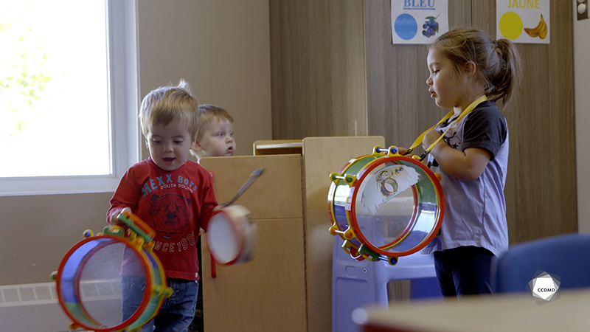
Video: Musical instrument

Objectives
- Analyzing the profession.
- Establishing positive communication in an educational childcare centre.
- Promoting children’s holistic development.
- Observing the development and behaviour of children.
- Building a positive relationship with children.
- Promoting positive behaviour among children, individually or as a group.
- Planning democratic educational interventions.
- Organizing the educational environment.
- Assessing educational quality.

Activity details
Approximate duration: 3 hrs

STEP 1
- Watch the video clip as a group or individually.
STEP 2
- Follow the instructions and fill out the table below:
- Share some examples observed in the clip for each of the following learning support strategies, in the context of language modelling.
LANGUAGE MODELLING
Learning support strategies | Examples
The educator uses strategies that allow the children to be continuously exposed to various language forms and uses.
The educator has meaningful interactions with the children.
The educator rephrases what the children say using more complex forms.
The educator asks open-ended questions that call for more elaborate answers.
The educator provides a model by describing what she does and what the children do.
Source: https://tout-petits.org/img/dossiers/qualite/Dossier-Qualite-Service-de-garde-GrilleEvaluation-V02.pdf
STEP 3
- Share your answers with the group.
STEP 4
- Watch the video clip for a second time as a group or individually.

STEP 5
- Expand your learning by answering the following questions as a group:
- When observing the educator in this clip, what caring attitudes do you notice? Share some examples.
- How would you describe the vibe in this clip? Share some examples.
- What are the attitudes and gestures of the educator that lead you to believe that she’s able to form a meaningful bond with the children in her group?

