SUGGESTED EXERCISES

# Exploratory play to boost fine motor and social skills in children aged 0–2

[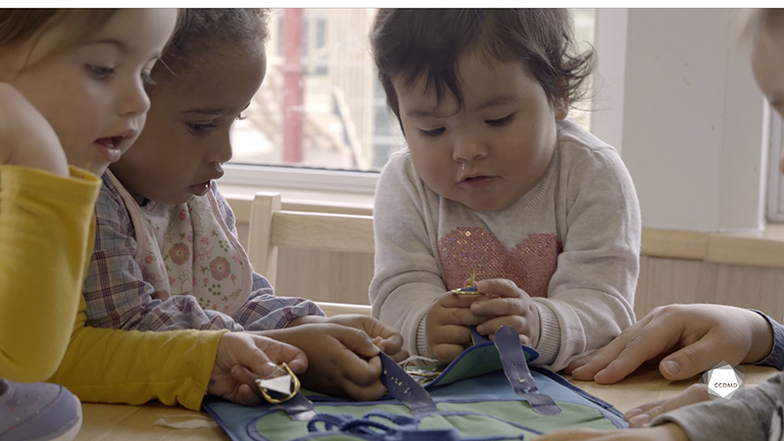](http://cpe-pn.ccdmd.qc.ca/fiche/apprendre-attacher-ses-lacets)

**Video:** [Learning to tie shoelaces](http://cpe-pn.ccdmd.qc.ca/fiche/apprendre-attacher-ses-lacets)

## Objectives

* Analyzing the profession.
* Observing the development and behaviour of children.
* Promoting children’s holistic development.
* Building a positive relationship with children.
* Building a relationship of trust with children’s families.
* Organizing the educational environment.
* Integrating the language and culture of belonging into educational practices.
* Assessing educational quality.

## Exercise details

Approximate duration: 3 hrs

STEP 1

1. As a group, brainstorm the following elements:

* Your knowledge of observation (theory and practice).
* What you’d like to explore further in this area.

STEP 2

1. Watch the video clip as a group or individually.
2. Individually, write your observations on a piece of paper.

STEP 3

1. As a group, take turns sharing these observations out loud.

STEP 4

1. Answer the following questions:

* In your opinion, which of the observations that you noted are judgments?
* If you were the parents of one of the children in the video clip and read the observations in the previous point, how would you react? Why?
* Which elements in this clip draw your attention the most or the least? Why?
* How might you set aside your emotions and personal values during a future observation?

1. If necessary, restate your observations to make them non-judgmental, objective, reliable and professional.

STEP 5

1. As a group or individually, watch the clip a second time and answer the following additional questions:

* What are the goals of the professional act observed?
* How do you develop your skills to perform professional observation?
* Why is it important to write down what you’ve observed? Could you simply rely on your memory?
* Should you only observe children whose development or behaviour captures your attention, or should you also look at children who are doing well? Why?
* Which elements in this clip draw your attention the most or the least? Why, do you think?

STEP 6

1. Identify the roles of an educational childcare centre (ECC) in promoting respect for and appreciation of culture and diversity.
2. Rewatch the video clip as a group or individually.
3. Identify the elements of this clip that show that the ECC is promoting cultural traditions and values.

STEP 7

1. To go further, as a group or individually, answer the following probing questions:

* What are the elements observed in this video clip that inform you about the educator’s pedagogical stance?
* What are the elements that you can observe in relation to the social development of children in the group?
* Why do you think the educator doesn’t say much during this clip? Does that bother you? Why?
* Why do you think the educator models the play once while the children are watching?
* What do you notice about health and infection control in this clip?
* If you were this educator and had to explain to parents the purpose of this exploration, what would you say to describe the spheres of motor and social development addressed in this activity?
* Is there a child that captures more of your attention? Why, do you think?
* Are the materials adapted to the children’s level of development? Why?