SUGGESTED EXERCISES

Observing a traditional storytelling activity
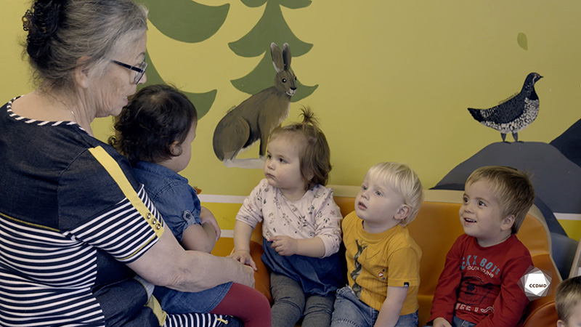
Video: Kukum Germaine tells the story of the wapush

Objectives
- Analyzing the profession.
- Creating a safe environment in an educational childcare centre.
- Establishing positive communication in an educational childcare centre.
- Promoting children’s holistic development.
- Observing the development and behaviour of children.
- Building a positive relationship with children.
- Planning democratic educational interventions.
- Organizing the educational environment.
- Facilitating active learning-based educational interventions.
- Integrating the language and culture of belonging into educational practices.
- Assessing educational quality.

Activity details
Approximate duration: 4 hrs
STEP 1
- Watch the video clip as a group or individually.
STEP 2
- As a group, take time to discuss the legend told by the educator in the video clip. Address the following elements:
- Takeaways from this activity, and why;
- Links to your own childhood, and why;
- Elements that made you smile in this clip, and why.
STEP 3
- Individually, create a story or legend for children.
STEP 4
- Make a room layout plan and a list of relevant materials that would help tell your story or legend to a group of children.
STEP 5
- In your place of employment or internship, plan an activity where children can create and tell their stories or legends, and use the room layout plan and list of materials created in Step 4.1.
STEP 6
- When you return to the classroom, share your experience in a discussion with the rest of the group.
STEP 7
- As a group, continue the discussion by asking the following questions:
- What is your takeaway from this exercise?
- What did you find easy or difficult to do, and why?
- If you had to do it again, what would you change? What would you do the same? Why?

Additional suggested exercises
- Work on the theory surrounding intervention styles. Demonstrate, using examples and professional observations, the intervention style used by the educator in the video clip.

