SUGGESTED EXERCISES

Observing free play in the morning
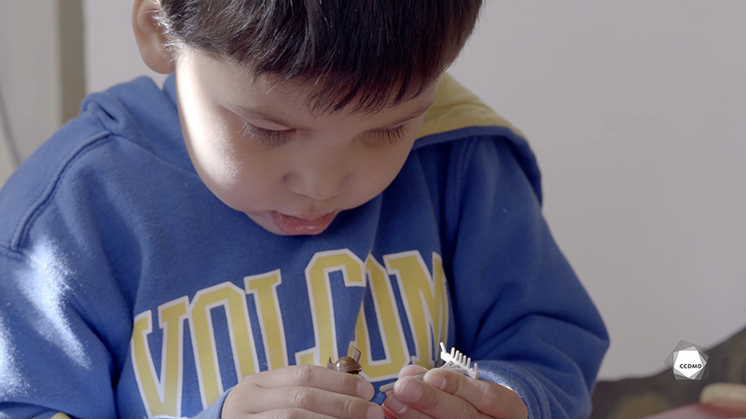
Video: Free play in the morning

Objectives
- Creating a safe environment in an educational childcare centre.
- Promoting children’s holistic development.
- Planning democratic educational interventions.
- Organizing the educational environment.
- Assessing educational quality.

Activity details
Approximate duration: 3 hrs

STEP 1
- Watch the video clip as a group or individually.
STEP 2
- Find concrete ways to ensure that the materials made available to children during free play in educational childcare centres (ECCs) meet the following criteria:
- They are safe;
- They reflect the diverse family and cultural realities;
- They promote non-stereotyped actions and values;
- They come in various formats, e.g., recycled, commercial, real-size, handmade;
- They support all the spheres of development;
- The stimulate the children’s senses.
STEP 3
- In teams of two or three, use your answers to make a list of materials that are appropriate for welcoming a mixed-age group with quality activities in the morning.
LIST OF MATERIALS FOR MORNING WELCOME ACTIVITIES IN A MIXED-AGE GROUP
(FREE PLAY)
Safe materials
Materials reflecting the diverse family and cultural realities
LIST OF MATERIALS FOR MORNING WELCOME ACTIVITIES IN A MIXED-AGE GROUP
(FREE PLAY)
Materials promoting non-stereotyped actions and values
Materials coming in various formats
Materials supporting all the spheres of development
Psychomotor development
Cognitive development
LIST OF MATERIALS FOR MORNING WELCOME ACTIVITIES IN A MIXED-AGE GROUP
(FREE PLAY)
Materials supporting all the spheres of development
Language development
Socio-affective development
Creative development
Sexual development
LIST OF MATERIALS FOR MORNING WELCOME ACTIVITIES IN A MIXED-AGE GROUP
(FREE PLAY)
Materials stimulating the children’s senses
Source: https://www.mfa.gouv.qc.ca/fr/publication/Documents/SF_echelle_observation_installation.pdf
STEP 4
- Share your answers with the group and discuss the layout and materials in ECCs.
STEP 5
- Watch the video clip for a second time as a group or individually.
STEP 6
- As a group, restart the discussion by asking the following questions:
- What do you think of the educator’s attitude when she asks the children to put away their toys and games? Why?
[Listen carefully, at the 2:00 mark, when she says: “OK. On ramasse!”.]
- How would you ensure that children experience smooth transitions?

Additional suggested exercises
- Observe the children’s motor development, particularly their fine motor skills, and explain their different motor development stages using objective observations.
- Draft an informational document for parents on the benefits of free play and mixed-age groups.

