SUGGESTED EXERCISES

Observing a Cree nursery rhyme activity
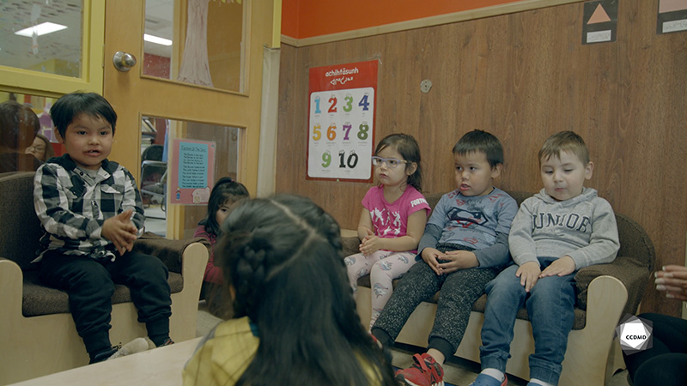
Video: Cree nursery rhyme

Objectives
- Analyzing the profession.
- Establishing positive communication in an educational childcare centre.
- Promoting children’s holistic development.
- Observing the development and behaviour of children.
- Building a positive relationship with children.
- Facilitating active learning-based educational interventions.
- Integrating the language and culture of belonging into educational practices.

Activity details
Approximate duration: 1.5 hrs

STEP 1
- Watch the video clip as a group or individually.
STEP 2
- Individually, fill out the table below by noting all the examples of verbal and non-verbal communication you can observe in the clip.
COMMUNICATION EXAMPLES
Verbal | Non-verbal

STEP 3
- In teams of two or three, answer the following questions based on your observations:
How does the educator’s verbal and non-verbal communication enable a positive contact with the child?
How does the educator’s verbal and non-verbal communication help establish a positive relationship with the child?
How does the educator’s verbal and non-verbal communication show an attentive and caring attitude toward the child?
How does the educator’s verbal and non-verbal communication show her availability?
How does the educator’s verbal and non-verbal communication show her ability to observe the child’s behaviour and development?
STEP 4
- Share your answers with the group.
STEP 5
- Watch the video clip one last time as a group or individually, and answer the following probing questions:
- What do you think of the space layout in this clip?
- Is the activity suitable to the interests of all the children present and their respective levels of development? Why?
- How does learning more than one language benefit children?

