SUGGESTED EXERCISES

Observing a group of children playing freely
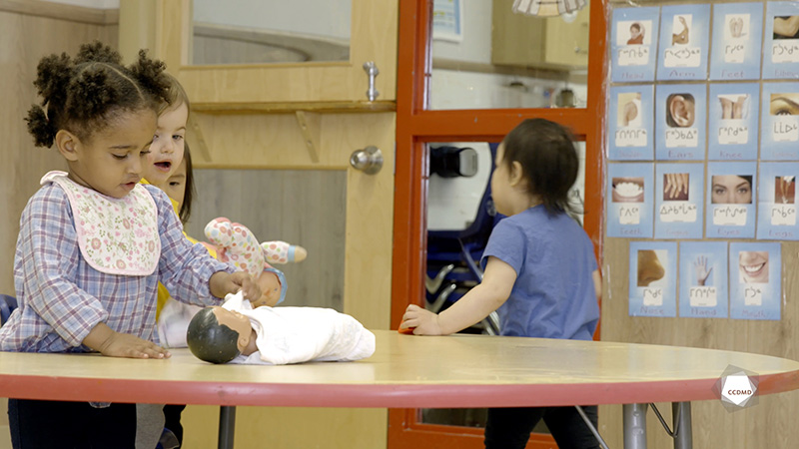
Video: Children playing freely

Objectives
- Analyzing the profession.
- Promoting a healthy lifestyle for children.
- Promoting children’s holistic development.
- Observing the development and behaviour of children.
- Planning democratic educational interventions.
- Organizing the educational environment.
- Facilitating active learning-based educational interventions.
- Integrating the language and culture of belonging into educational practices.

Activity details
Approximate duration: 3 hrs

STEP 1
- Watch the video clip as a group or individually.
STEP 2
- Individually, write down in the table below any elements observed in the video clip that relate to the cognitive, affective and social development of children in this group.
Cognitive development

Social development

Affective development
STEP 3
- Together as a group, go around the table and let everyone share their answers.
- Answer the following questions about free play and its influence on child development:
- Is free play a right? Why?
- How would you define free play?
- What are the benefits of free play for a child’s cognitive, social and affective development?
- Does indoor free play have the same impact as outdoor free play? Why, do you think?
- What are the educator’s role and mandate during free play time?

STEP 4
- Watch the video clip for a second time as a group or individually.
STEP 5
- Describe how the benefits of free play relate to First Nations’ values.
Note the benefits of free play for a child’s development below.

What elements of Indigenous culture and educational values are consistent with free play?
Examples: kindliness, confidence in children, cyclical learning.
STEP 6
- In teams of three, do the education planning of a free play activity that integrates the following elements of Indigenous culture:
- Listening, smelling, touching, tasting;
- Consciousness, heart, body, spirit;
- Self-respect, respect for other people, the earth and the spiritual world;
- Four sacred elements: air, water, earth, sun.
STEP 7
- Each team makes a list of the materials and games needed for their planning.
Materials | Games

STEP 8
- Each team shares their room layout plan with the group.
STEP 9
- Together as a group, start a discussion around the following question:
- What is your takeaway from this activity?

Additional suggested exercises
- Answer the following questions with recommendations:
  - What can parents, educators, school boards and municipalities in a child’s environment do to expand access to free play?
  - What are strengths that Indigenous communities could build upon to implement educational practices that promote free play?
- Form a sharing circle and discuss social pressure, overprotection and supervision issues around our children, and the proper balance needed to allow free play.

