SUGGESTED EXERCISES

Observing calming and yoga activity
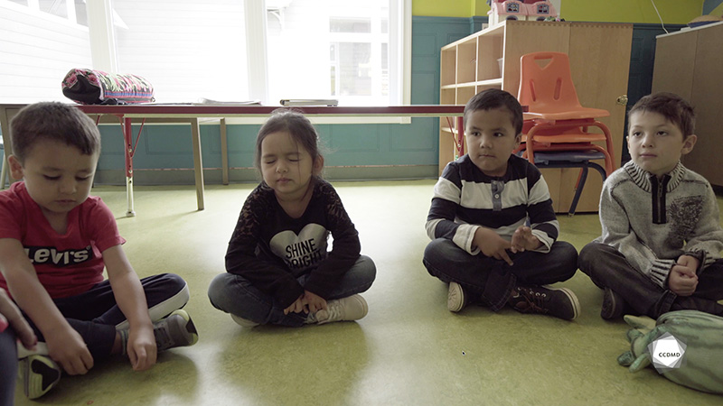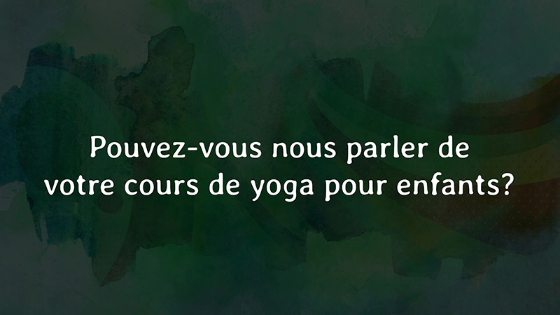
Videos: Calming activity and Please tell us about your yoga classes for children

Objectives
- Promoting a healthy lifestyle for children.
- Promoting children’s holistic development.
- Observing the development and behaviour of children.
- Building a positive relationship with children.
- Promoting positive behaviour among children, individually or as a group.
- Facilitating active learning-based educational interventions.
- Assessing educational quality.

Activity details
Approximate duration: 3 hrs

STEP 1
- Watch the video clip as a group or individually.
STEP 2
- In the table below, note the educational intentions that led to this calming yoga activity.
In your opinion, what are the educational intentions of planning and organizing a yoga activity for the children?
STEP 3
- Share your answers to build a common list that will help understand the importance of educational intentions.
Source: Ministère de la Famille (2019). Accueillir la petite enfance: Programme éducatif pour les services de garde éducatifs à l’enfance. Gouvernement du Québec.
STEP 4
- As a group or individually, watch the video clip of the interview with Chantal Niquay, “Please tell us about your yoga classes for children.”

STEP 5
- As a group, answer the following question:
- Does the educational intention behind the “Calming activity” clip correspond with the reasons raised by the educator, Chantal Niquay, in her interview on the topic? Why, and how so?
STEP 6
- Continue the discussion by asking the following questions:
- What do you do with the children to help them move from an intense activity to a quieter time?
- Does the word “calm” mean anything to children? Why?
- How can you support children in understanding the concept of finding their inner calm?
- In your opinion, is yoga a lifestyle habit to be incorporated into an educational childcare centre? Why?

