SUGGESTED EXERCISES

Observing a moment of play with a toy lawnmower
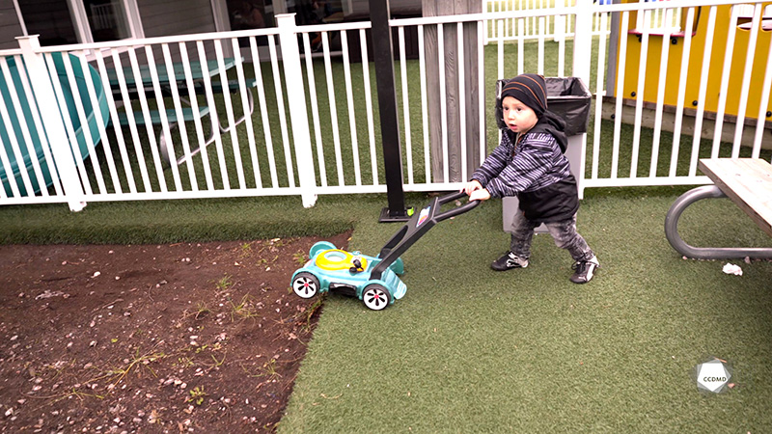
Video: Benjamin is mowing the lawn

Objectives
- Promoting children’s holistic development.
- Observing the development and behaviour of children.
- Organizing the educational environment.

Activity details
Approximate duration: 1 hr

STEP 1
- Watch the video clip as a group or individually.
STEP 2
- In teams of two or three, fill out the table below by noting your observations in relation to the motor development sphere:
DEVELOPMENT SPHERE | MY OBSERVATIONS
Motor
STEP 3
- In teams of two or three, identify how the layout of the outdoor environment relates to the children’s development. Then, answer the following questions:
- How does the garden patch become an exploratory space for the children?
- How could the lawnmower game be included in the planning of educational activities?
- How can the garden patch support the children’s holistic development?
- When observing the child pretending to mow the lawn in the garden and on a patch of artificial grass, and his interest for this game, what are your ideas for the outdoor space layout?
STEP 4
- Expand your learning by watching the clip again, as a group or individually, and answering the following questions:
- Why is the garden patch necessary in the layout of the yard?
- What do you think of the artificial grass?

