SUGGESTED EXERCISES

Observing an exploratory activity and a beaded embroidery activity
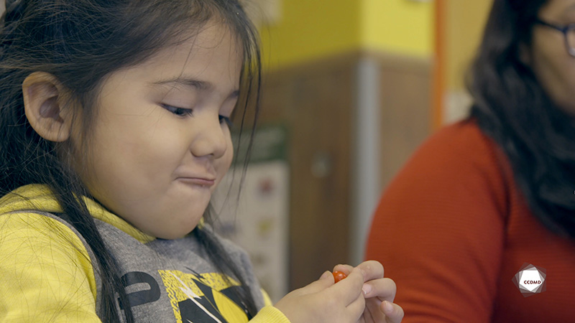
Video: Beaded embroidery

Objectives
- Promoting children’s holistic development.
- Observing the development and behaviour of children.
- Planning democratic educational interventions.
- Organizing the educational environment.
- Integrating the language and culture of belonging into educational practices.
- Working with children with special needs.

Activity details
Approximate duration: 3 hrs

STEP 1
- Watch the video clip as a group or individually.
STEP 2
- Watch the video clip for a second time, individually. Put yourself in the shoes of the educator you see in the clip.
STEP 3
- Fill out the child observation table below while keeping in mind the following questions:
- What elements of child development did I observe in the clip that make this activity relevant?
- What elements of a child’s life did I have to consider when planning this activity?
CHILD OBSERVATION TABLE
Spheres of development | Child’s development stage or zone of proximal development
Motor
Language
Cognitive
Affective
Social
Child’s interests
Other elements in a child’s life and environment to consider:
Why did I choose this activity?
STEP 4
- Share and compare your answers with the group.
STEP 5
- Watch the video clip for a third time as a group or individually and answer the following question:
- What elements do you observe in this clip that show how important it is to align educational practices with the child’s language and culture of belonging?
STEP 6
- To go further, answer the following probing questions:
- If you were in the educator’s shoes, would you do anything differently? Why?
- What elements can you observe that show the educator’s availability for the children in her group?
- How can this exploratory activity be adapted for children with special needs to support their development?
- What is your takeaway from this activity?

