SUGGESTED EXERCISES

Observing free play in the nursery
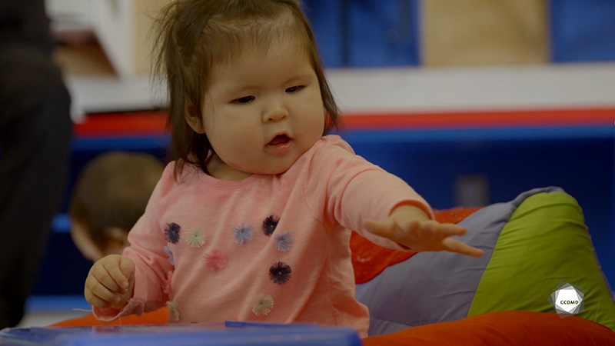
Video: Baby playing freely

Objectives
- Promoting a healthy lifestyle for children.
- Creating a safe environment in an educational childcare centre.
- Promoting children’s holistic development.
- Building a positive relationship with children.
- Building a relationship of trust with children’s families.
- Organizing the educational environment.
- Integrating the language and culture of belonging into educational practices.

Activity details
Approximate duration: 4 hrs

STEP 1
- Watch the video clip as a group or individually.
STEP 2
- Divide the group into three teams and have each group prepare a short oral presentation. The instructions are as follows:
- Each team receives a topic and talking points related to the video clip.
- Each team has 30 minutes to prepare by searching the internet or consulting reference materials.
- Each team has 10 minutes to present to the rest of the group and interact with colleagues.
- During their presentation, each team needs to integrate the other group members to keep the conversation going and encourage discussion.
- The teams follow their respective assigned topics and instructions:

TEAM 1: Facilitate an educational team meeting with an agenda that includes the following topics:
- Identify, in a professional manner, what the children are learning during this free play.
- Identify and explain the key elements of infant development observed in this video clip.
- Identify and explain the important elements to be considered in the nursery layout to promote free play.
- Identify and explain ways to create a meaningful and lasting relationship with the infant.
- Develop a list of materials that could be added to a room for 0-to-18-month-olds to align educational practices with the language and culture of belonging.

TEAM 2: Prepare and facilitate an information session for parents in the educational childcare centre that addresses the following points:
- Support parents in their understanding of free play and its importance in a child’s development.
- Support parents in observing their child’s development.
- Support parents in recognizing their baby’s real needs.
- Equip parents to choose educational materials for their infant to encourage holistic development.

TEAM 3: Prepare and facilitate a nursery development conference respecting the following points:
- Submit a layout plan for a nursery that promotes sensory exploration and free play among 0-to-18-month-olds.
- Identify and explain the elements observed in the video clip that demonstrate that the living space is comfortable and warm.
- Make a list of materials that could be incorporated into a room for 0-to-18-month-olds to align educational practices with the language and culture of belonging.
STEP 3
- Make the presentations.
- You must leave time for a question period at the end of each presentation.
STEP 4
- Back in the main group, restart the discussion to continue learning by answering the following additional questions:
- What is the role of the educator during free play?
- What did you find surprising in this clip?
- For the child, what are the benefits of being able to play freely?
- What is your takeaway from this activity?
- What do you think is most important for your future practice and profession?

