SUGGESTED EXERCISES

Observing nap time routine in the nursery
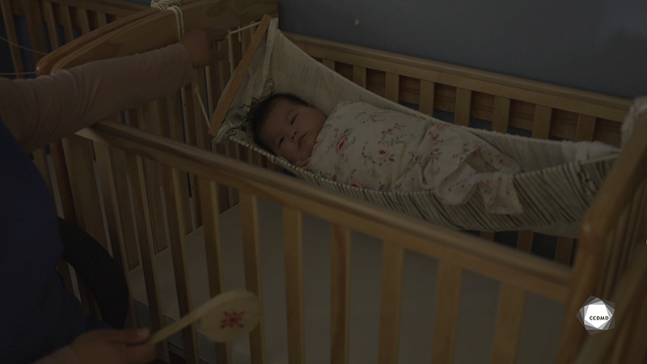
Video: Baby napping

Objectives
- Analyzing the profession.
- Promoting a healthy lifestyle for children.
- Creating a safe environment in an educational childcare centre.
- Promoting children’s holistic development.
- Building a positive relationship with children.
- Organizing the educational environment.
- Integrating the language and culture of belonging into educational practices.

Activity details
Approximate duration: 2 hrs

STEP 1
- Watch the video clip as a group or individually.
STEP 2
- Individually, check off any skills you can observe in the clip in the table below.
STEP 3
- Individually, explain your answers in the space provided, and discuss the importance of each practical skill and soft skill.
QUALITATIVE ASSESSMENT OF SKILLS
SKILLS | CAN IT BE OBSERVED IN THE CLIP? |  | DISCUSS THE IMPORTANCE OF USING  THIS PRACTICAL OR SOFT SKILL.
 | Yes | No
PRACTICAL SKILLS
Meeting the children’s developmental needs
Meeting the children’s safety needs
Meeting the children’s affective needs
Supporting the children in leaving their parents for the day
Feeding the children and helping them eat
Changing diapers
Supporting the children in learning how to use a potty
Getting the children dressed or helping them get dressed
Helping the children at nap time
Teaching a healthy lifestyle
Fostering a stimulating environment
Ensuring an appropriate pedagogical, physical and material planning of the space
Building a relationship with the parents
Establishing a partnership with the parents
Performing interventions and planning tasks regarding the children’s health and safety
Following sanitary guidelines
Building a meaningful relationship with children
Meeting the parents’ requirements
Ensuring constant monitoring
Planning everyday moments that meet the children’s needs
Observing the children’s development and behaviour
Performing interventions regarding the children’s safety (screening and protection)
Discussing their work with colleagues and management
Respecting the pace of children and their parents
Reassuring the children and their parents
Honouring and respecting the transmission of family and cultural values
SOFT SKILLS
Caring
Listening
Being organized with the help of tools
Working in teams
Being calm
Being creative
Demonstrating professional ethics
Being empathetic
Being energetic
Having self-control
Being emotionally mature
Being open-minded
Having a good sense of humour
Being responsible
STEP 4
- Share your answers with the group.
STEP 5
- Expand your learning by answering the following questions:
- What is your first impression when watching this clip?
- Is it a professional or personal reaction? Why?
- Share some examples of elements you can observe in the clip that show how the environment supports the children’s holistic development.
- Share some examples of things you can hear in the clip that show how the environment supports children’s affective development.
- What role do the parents play in the planning of nap time in educational childcare centres?
- If you were in the same situation, what would you do differently? Why?
- What elements can you observe that show the educator’s availability for the children in her group?
- What is your takeaway from this activity?

