SUGGESTED EXERCISES

Observation of outside playtime
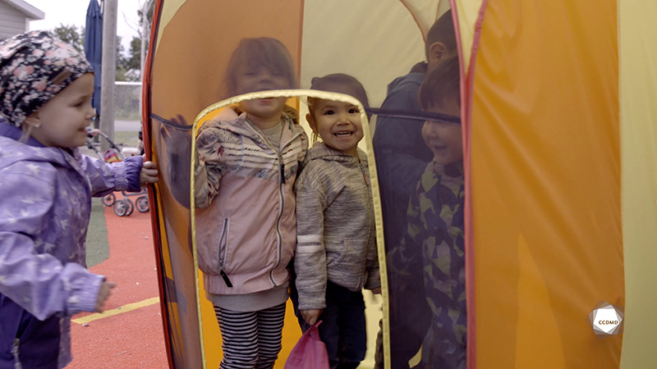
Video: A tent party

Objectives
- Analyzing the profession.
- Promoting a healthy lifestyle for children.
- Creating a safe environment in an early childhood education childcare service.
- Promoting children’s holistic development.
- Building a positive relationship with children.
- Planning democratic educational interventions.
- Organizing the educational environment.
- Facilitating active learning-based educational interventions.
- Integrating the language and culture of belonging into educational practices.
- Assessing educational quality.

Activity details
Approximate duration: 4 hrs
STEP 1
- Watch the video clip as a group or individually.
STEP 2
- Individually, with pictures, paint or any other craft material, create a poster that includes the following elements:
- The most positively meaningful childhood memories that you experienced with friends;
- The most positively meaningful childhood memories that you experienced while playing outside;
- The significant adults in your childhood;
- The most positively meaningful places of your childhood.
- Draft a presentation text for your poster.
STEP 3
- Everyone shares their poster and reads their text for the group.
STEP 4
- Watch the video clip for a second time as a group or individually.
STEP 5
- In the table below, note any elements observed in the video clip that are either positively meaningful or not meaningful for children’s holistic development.
MEANINGFUL FOR DEVELOPMENT | NOT MEANINGFUL FOR DEVELOPMENT
Interventions by an adult
Available materials
Space layout
Space safety planning
STEP 6
- Answer the following questions in writing based on your observations:
- If you were an educator in this educational childcare centre, how would you give children the opportunity to connect with nature in an even more meaningful way?
- Do you think playing in the tent is safe? Why?
- Would you change anything in this clip to make it safer? What? Why?
- How do you define risk-taking?
- How important is it in children’s overall development?
- If you were a child in this play environment and in the tent, would this playtime become a positively meaningful memory for you? Why?
STEP 7
- Share and compare your answers with the group.
STEP 8
- Watch the video clip for a third time as a group or individually.
STEP 9
- Think about the symbol of the tent and imagine a group of children playing in a big tent or a teepee (wigwam) big enough for all of them. Then, imagine this tent in a pristine natural environment.
- Answer the following questions to push your professional reflection further:
- Can playing in this type of tent be meaningful for children? Why?
- What are the benefits of allowing children to play in a natural environment?
- Should all children in an educational childcare centre have the opportunity to play in a natural environment? Why?
- As an educator, what is your role in implementing educational actions that are positive for children and their families with regard to various intensity levels of outdoor play, contact with nature and risk-taking?

